Iv - ASSIGNMENT

1. Declare a div () function with two parameters. Then call the function and pass two numbers and display their division.

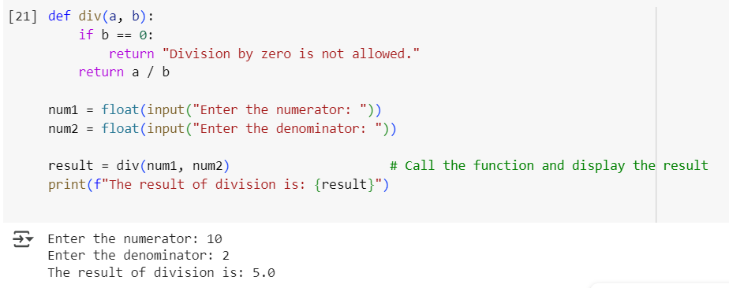

Output

Enter a numerator:10

Enter a denominator :2

The result of division is :5.0

1. Declare a square () function with one parameter. Then call the function and pass one number and display the square of that number.

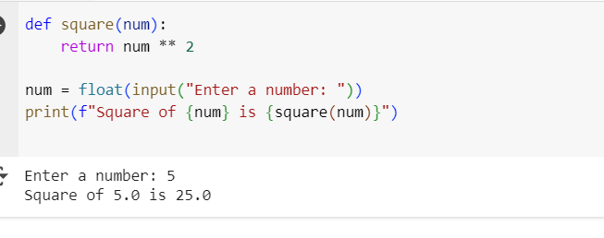Output

Enter a number :5

Square of 5.0 is 25.0

1. Using max () and min () functions display the maximum and minimum of 5 random number.

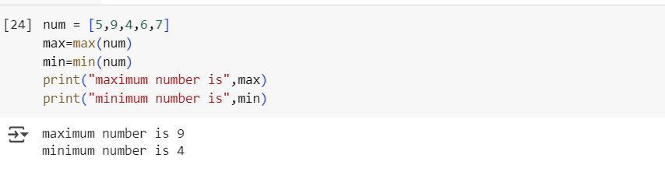

Output

Maximum number is 9

Minimum number is 4

1. Accept a name from the user and display that in lower case using lower () function.

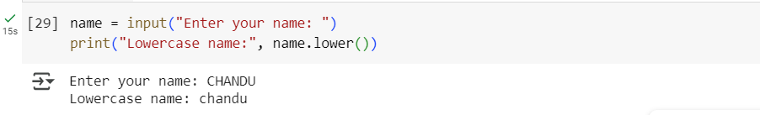

Output

Enter your name: CHANDU

Lower case name: chandu

1. Write a lambda function that takes one argument and returns ‘Positive’ of the number is greater than 0, ‘Negative’ if it is less than 0, and ‘Zero’ if it is 0. Test it with different numbers.

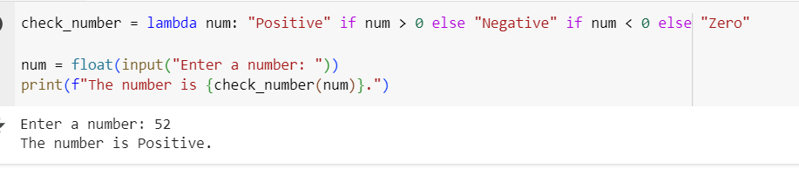

Output

Enter a number :52

The number is positive.